Let’s learn Spanish with paper game Oflameron

Ñ | U | O | B | Y | R | Z | E | P | W | Q | A | X | D

S | CH | F | G | H | J | K | B | T | L | P | rr | C | V

LL | M | N | Y | A | E | C | H | O | I | L | Q | K | N

One of the variants of play Oflameron for Spanish lesson with children 6-7 years plus.

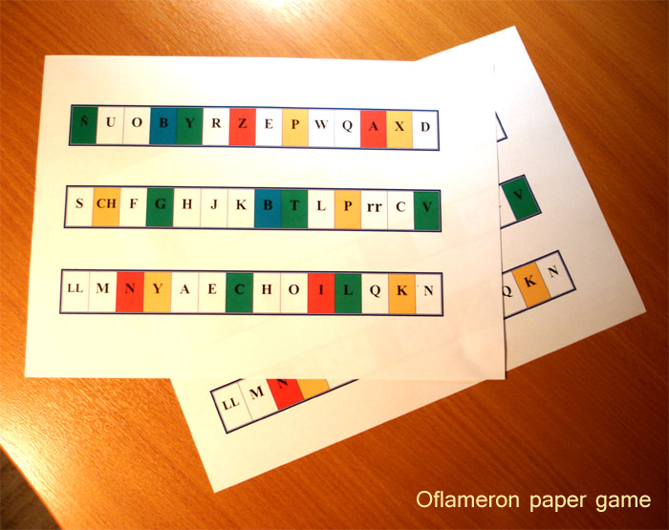 - Sample

It is necessary to do some rows of boxes with letters of Spanish alphabet (if Spanish is under study). Minimum number of rows is 3-4. If there is more rows, you can use them than as for change in the field of play. You will need the usual stacks of chips and die.

The field of play consists of 3-4 rows, which are laid out as a table – one row over the other. The players are given 10-15 TRANSLATIONS of Spanish words. For example, telephone, assign, dimension and so on. For which purpose – it will be shown later.

How to play

For a start of the play the players put their chips on ANY boxes of the BOTTOM row: for example, like that:

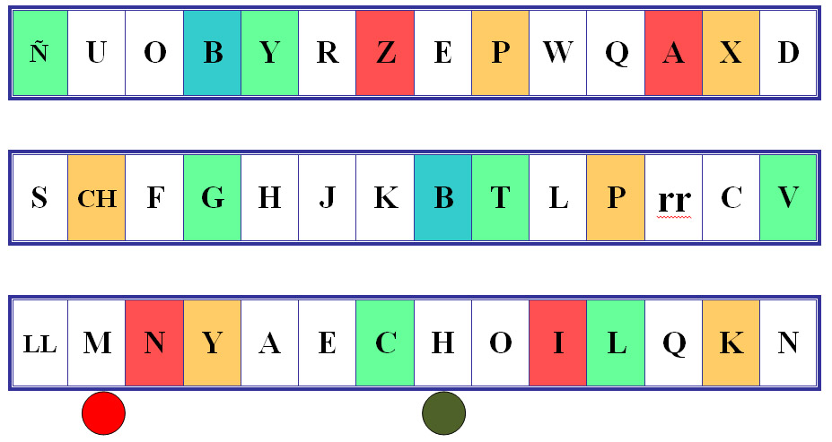

and write down the occupied Spanish letters – every player writes down his own letters. In this example, the first player will write down the letter “M”, and the second player – the letter “H”. After that the players throw die by turn and move their chips ONE ROW ABOVE and as many boxes RIGHT or LEFT in the row as many points are there on the die. To which side in the row (to the right or to the left) the chip should be moved the player decides by himself.

If during the moving of the chip along the row, there is lack of boxes, the moving on the further side of the same row is performed and the remaining number of the boxes should be counted on the other end (as if the row is glued together as a ring).

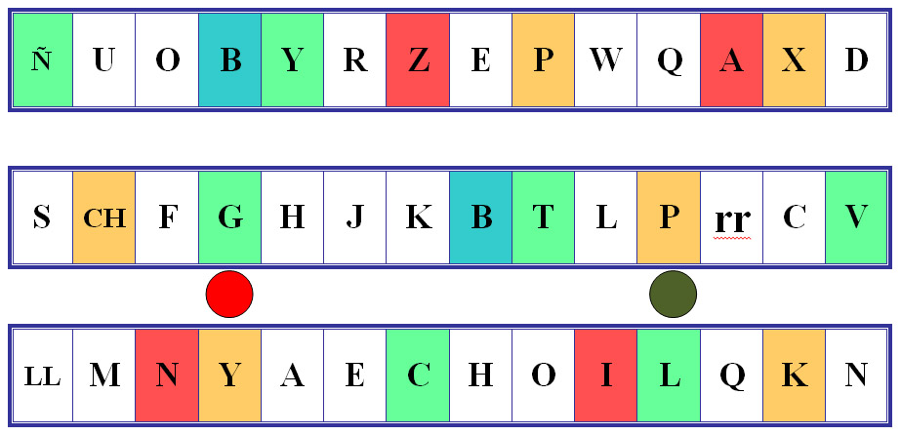

Now the first player (with red chip) will write down the letter “G”, and the second player (with green chip) will write down the letter “P”.
The bottom row of the boxes, which was “left” by chips of the players, is placed to the pack
and the new row of the boxes from the pack is laid out on the top.

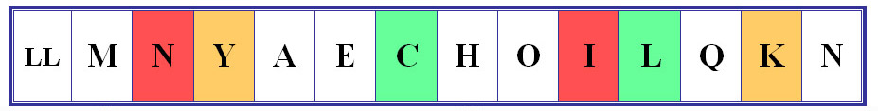

If we have only three game rows, the bottom row will be shifted to the top.

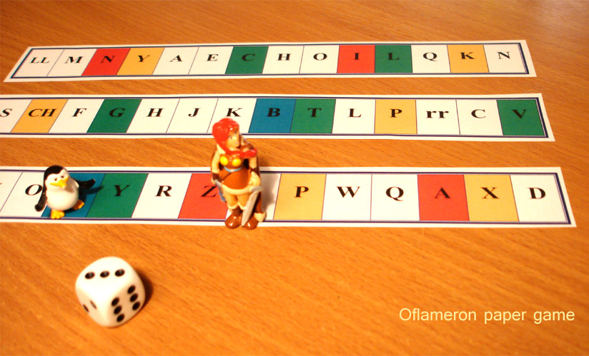 - Sample
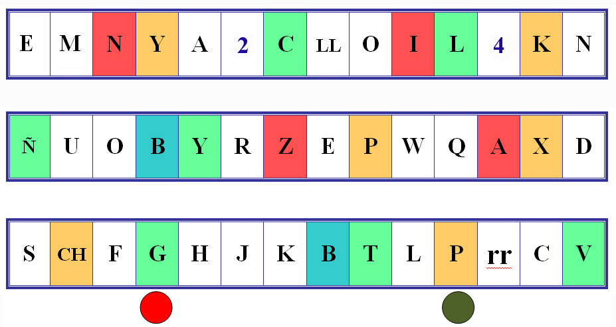

On such a way the continuity of the field of play for the upward movement of chips is assured.

The players throw the die, move the chips, collect Spanish letters, throw the die again and move the chips and so on. At some time the collected letters will be enough for compilation of words in Spanish. After every movement of the chip the player can name one compiled Spanish word with length no less than 4 letters and its translation. Therefore the player gets as many points as many letters are there in the Spanish word.
The used letters are crossed out from the list of the collected letters. For example, the player has collected the letters “N”, “T”, “E”, “E”, “X”, “L”, “E”, “F”, “O”, “N”, “O”. From this letters the word “TELEFONO” can be compiled. The letters “N”, “E”, “X” will stay with the player.

For the word “TELEFONO” the player will get 8 points. But in case the TRANSLATION of this word telephone was among those 10-15 TRANSLATIONS, which were stated before the game start, the player will get double amount of points.

If the compiled Spanish word turned out to be the longest in the game at the moment (current record), then the player will get triple number of points. This makes it possible for underperformer to catch up the leaders. During one game some current records can be broken.

End of game

The play finishes, when all the 10-15 Spanish words are compiled and named, TRANSLATION of which was specified before the game. After this the number of gathered points is counted and the winner is determined. If several players have got the same amount of points, the winner is the person, who has compiled and named the longest Spanish word.

During one game the player can compile and name many tens of Spanish words. In the process of game the mind of the participants should constantly travel over the known Spanish words, trying to fit the needed one for the set of letters they have. This provides high efficiency of the training of the vocabulary. After some games the players will choose the words much faster by making phrases in Spanish.

If we replace the alphabet in the rows of game, we can learn any other foreign languages.

To maintain the interest in game the additional values of boxes can be used in the rows.
For example, for some boxes the numeral values can be set. For example, [2] and [4]. This allows to implement the system of bonuses in the game and to heighten interest.

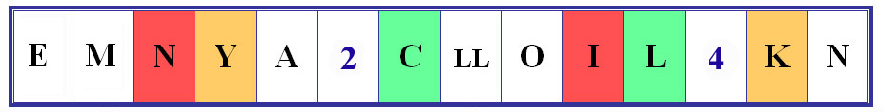

If the player’s chip takes the box with value of 2 or 4, the player will gain the right to write down for himself [2] or [4] ARBITRARY Spanish letters, which he is missing for compilation of words. To heighten interest in the game you can introduce in the game other numeral values, for example [6] and [8].

If more experienced players are taking part in the game, the additional scenarios of training can be implemented. For this we can add the value of the box “triangle” and will use the special cards with fragments of Spanish words.

Example of the box

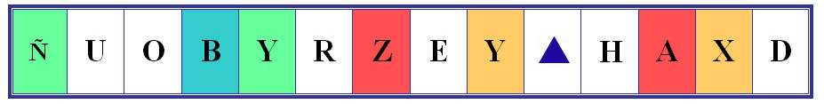

Example of the card with fragment of Spanish word

If the chip of the player takes the box with value “triangle”, the player takes the card with fragment of Spanish word from the pack. For example |SUPER…| and should name in the same time the whole word and its translation. In this example it can be |SUPERFICIE| - surface.

If the answer is right, the player can get as many points as many letters are there in the Spanish word. This means that the player can get points without using the collected letters. If the used card allows compiling the other Spanish words it stays in the game and is returned to the pack. If the participant of the game cannot name the word, the right is transferred to the next player.

The game allows learning every European language. It is enough just to replace the Spanish letters with the letters of other alphabet.

All the materials of the game you can download and print free, or prepare by yourself, using paper and pen. You can organize the training process during 20 minutes. It is enough to remember the rules of the game.

The Game Oflameron is absolutely free for using in the learning process. It is necessarily to save the name and rules of the game.

Another version Oflameron game http://www.oflameron.ru Translate online

